Wireframes

Amelia Poole

CIS134 Web Style & Design

7/2/23

Homepage - Wireframes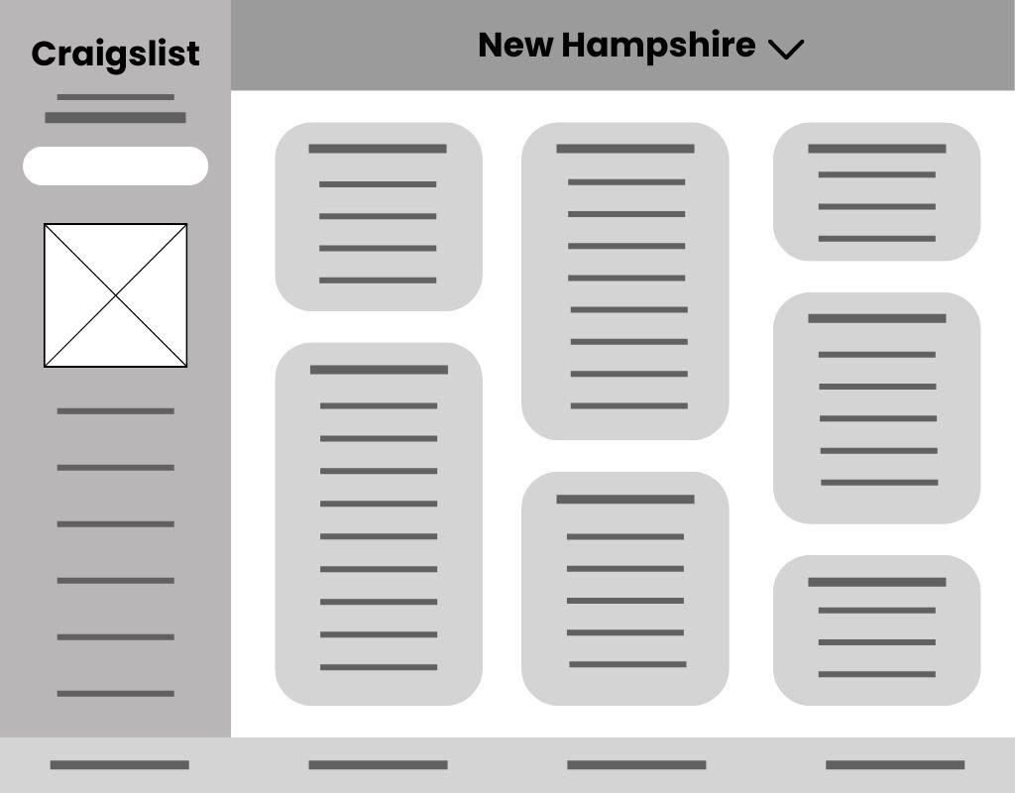

Desktop - 1024x800px



Tablet -

768x1100px

Mobile -

320x600px

For Sale Page - Wireframes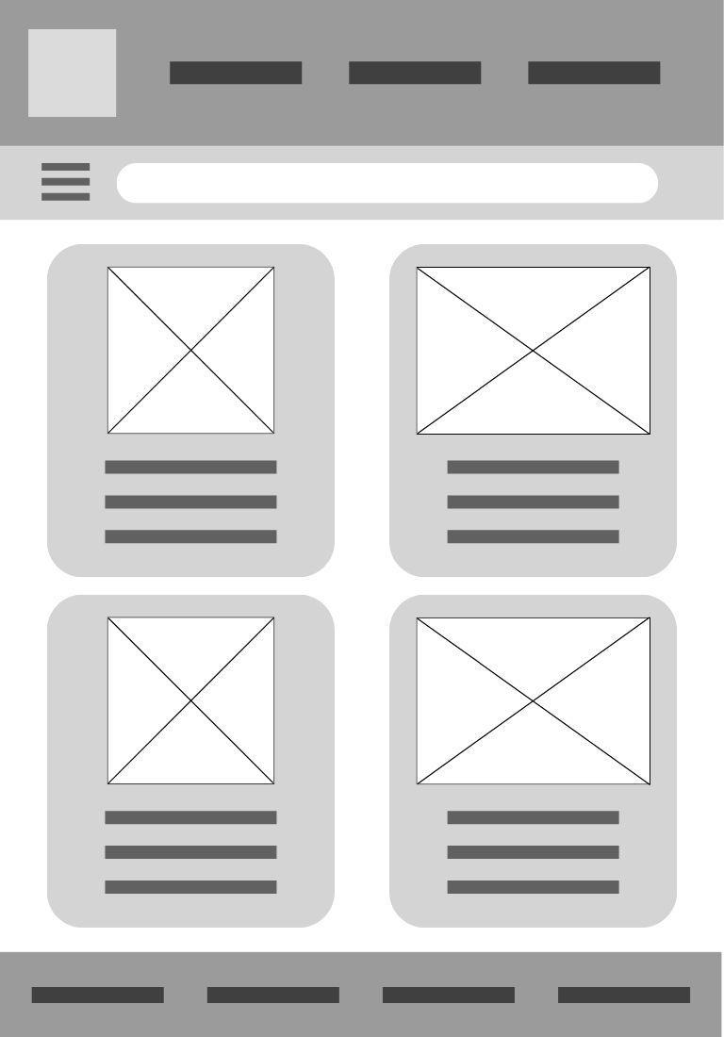

Mobile - 320x600px

Tablet -

768x1100px

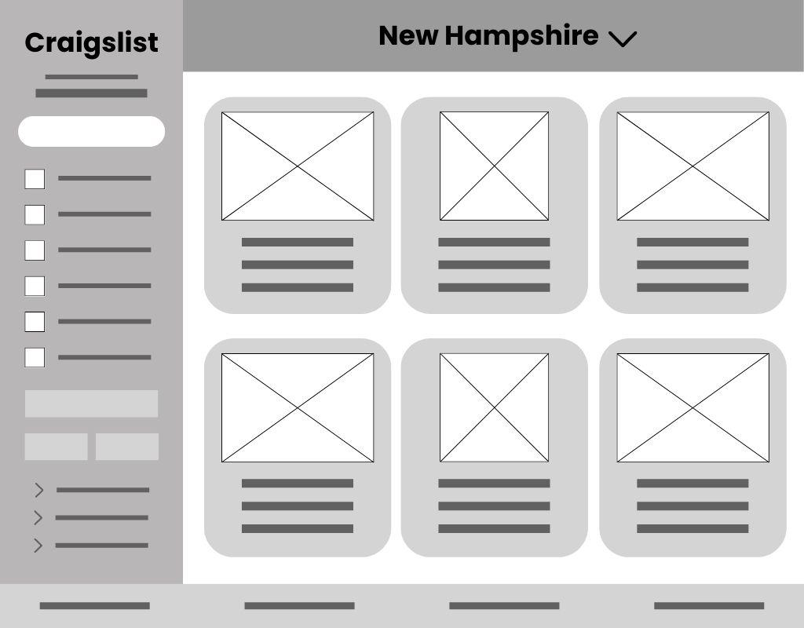

Desktop - 1024x800px

Forum Page - Wireframes

Tablet - 768x1100px

Mobile - 320x600px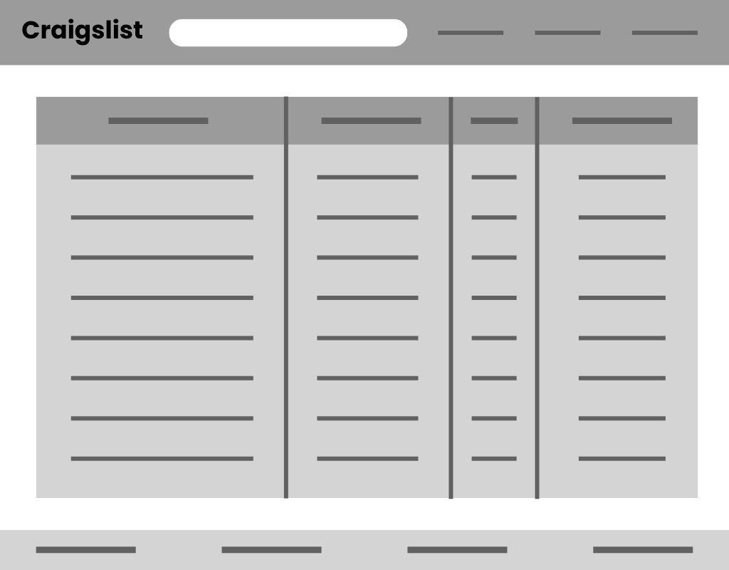

Desktop - 1024x800px